The DataViz Challenge - Transforming EDA Projects to Dashboards
Submitted by:
JITESH SACHDEV
Data Science Learner, AlmaBetter
Create a compelling Tableau/PowerBI Dashboard from the same dataset used for EDA.

Problem Statement:
In the context of Superstore operations, how can data visualization tools like Tableau Desktop, Tableau Public, or Power BI be leveraged to uncover actionable insights related to sales performance, profitability, regional trends, and product-level growth?
This project aims to analyze and visualize Superstore’s sales and profit metrics across key dimensions such as region, category, sub-category, customer segment, and shipping mode. The goal is to assist management in identifying growth opportunities, enhancing decision-making, and addressing loss-making areas effectively.

Dataset Selection:
For this project, we are using the popular Superstore Sales dataset, which contains transactional-level retail data including sales, profit, region, and product details.
Dataset Name: Superstore Sales Data
Source: Kaggle / Provided by Instructor
Description: Contains historical sales transactions including customer details, product data, sales, profit, quantity, region, category, and shipping information.

Why Superstore Dataset?
The Superstore dataset simulates real-world retail operations and is ideal for performing EDA, business analysis, and dashboard visualizations. It helps in understanding customer behavior, regional demand, profitable product categories, and inventory decisions.
Key Stats:
- 10,000+ transactional records
- 13+ key variables like sales, profit, category, region
- Ideal for time-series and categorical visualizations

Key Attributes:
- Order ID, Order Date, Ship Date
- Customer ID, Customer Name, Segment
- Product ID, Category, Sub-Category, Product Name
- Region, State, City
- Sales, Quantity, Discount, Profit
- Shipping Mode

Problem Areas to Explore:
- Which regions and states are generating the most sales and profit?
- What are the high-performing and low-performing product categories?
- Which customer segments bring the most revenue?
- How do discounts impact profit margins?
- Are certain shipping modes affecting delivery speed or profitability?

Dashboard Structure (Divide into 4 Sections):

Overview Section
- KPIs: Total Sales, Profit, Quantity, Average Discount
- Year-wise and Month-wise Sales Trend
- Profit vs Sales Comparison

Regional Analysis
- Sales & Profit by Region and State
- Map visualization of sales performance
- Region-wise profitability ratio

Product Performance
- Category & Subcategory-wise Sales & Profit
- Top 10 Products

Customer & Shipping
- Segment-wise Sales Distribution

Superstore Performance Dashboard

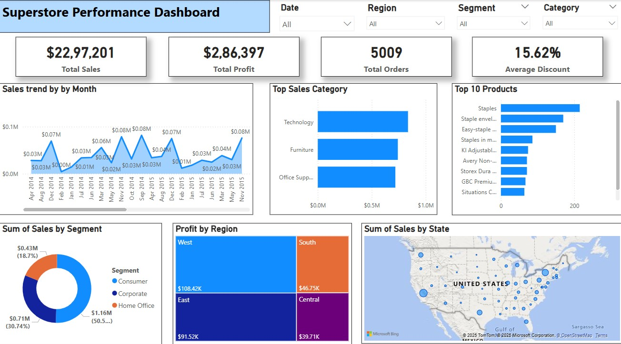

Dashboard Development Process

Data Cleaning:
- Removed duplicates and null values
- Fixed incorrect date formats
- Standardized category and subcategory names

Data Transformation:
- Created calculated fields:
- Profit Ratio
- Discount Bucket
- Sales per Order
- Grouped sub-categories for simplified visuals

Tool Used:
- Tableau Public (Free version)
- Used filters for interactive exploration (Segment, Category, Region)
- Color-coded charts for intuitive navigation

Insights Derived:
- The West region has high sales but low profit margins in some categories.
- The Technology category outperforms others in terms of profitability.
- Higher discounts lead to lower profit despite increased sales volume.
- Same Day shipping has the lowest profit margin among all shipping modes.

User Experience:
- Applied dynamic filters for users to drill down data
- Interactive tooltips and annotations
- Intuitive layout using consistent colors and typography

Conclusion
This dashboard offers a comprehensive view of Superstore’s business performance. By leveraging visual analytics, key trends and improvement areas have been uncovered, helping stakeholders make data-driven decisions confidently.

Attachments:
- PowerBI file:
https://drive.google.com/file/d/1iZsnTIwRopd9nz4fgsxVdtTDEPi32Nls/view?usp=sharing
- Data.csv file:
https://drive.google.com/file/d/1vdJRZkky3RXJhK92xjkJUnReNrwu4EbK/view?usp=sharing
- EDA file:
https://colab.research.google.com/drive/1qcfL2at36uOdMC7LrL636rFH71LkNSrr?usp=sharing

